**Introduction to lathe Machine perform straight turning and calculate machining time.**

**Apparatus:**

Lathe machine, stop watch, tachometer, MS rod.

**Figure:**

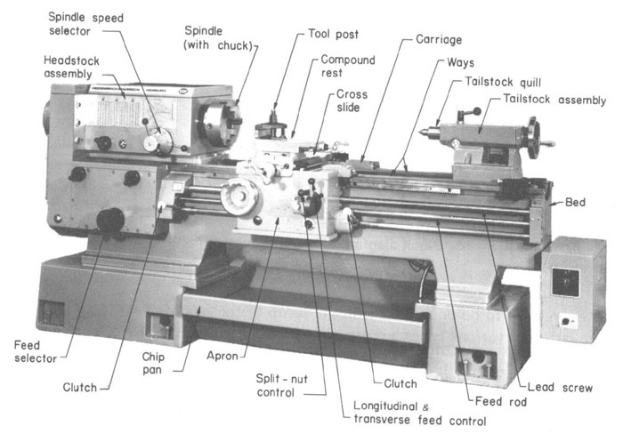

**Head stock**

**____________________________________________________________________________________________________________________________________________________________**

**Tailstock**

**____________________________________________________________________________________________________________________________________________________________**

**Lead screw**

**____________________________________________________________________________________________________________________________________________________________**

**Feed Rod**

**____________________________________________________________________________________________________________________________________________________________**

**Carriage**

**____________________________________________________________________________________________________________________________________________________________**

**Half Lock lever**

**____________________________________________________________________________________________________________________________________________________________**

**Apron**

**____________________________________________________________________________________________________________________________________________________________**

**Observations & Calculations:**

Number of passes=Nt=

Feed Rate=Fr=----------------- (mm\mint)

|  |  |  |  |  |  |  |  |  |  |  |
| --- | --- | --- | --- | --- | --- | --- | --- | --- | --- | --- |
| Sr.No | Length of rod  L | Initial diameter  Di | Final Diameter  Df | Depth of cut= $$\frac{Di-Df}{2xN}$$ | RPMs | Cutting Speed  Vi= | Feed  F=Fr\RPM | Machining Time  TM=xNt | Actual Time  Ta | Idler Time  Ta-Tc |
|  | mm | mm | mm | mm |  | mm\mint | mm\rev | mint | mint | mint |
| 1 |  |  |  |  |  |  |  |  |  |  |
| 2 |  |  |  |  |  |  |  |  |  |  |
| 3 |  |  |  |  |  |  |  |  |  |  |

**Specimen Calculations**

**Questions**

How straight and Taper turning differ?

__________________________________________________________________________________________________________________________________________________________________________________________________________________________________________

How many linear & rotational axis a lathe machine has?

______________________________________________________________________________________________________________________________________________________________________________________________________

Write different types of slideways ?

______________________________________________________________________________________________________________________________________________________________________________________________________

What are standard cutting speed, depth of cut and feed for Mild steel?

____________________________________________________________________________________________________________________________________________________________

**Comments on**

How to reduce idler time

______________________________________________________________________________________________________________________________________________________________________________________________________________________________________________________________________________________________________________________________________________________________________________________________________________________________________________________________________________